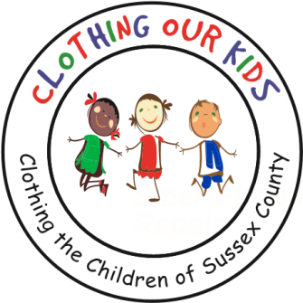
26582 John J. Williams Hwy Ste 2
Millsboro, DE 19966
302-864-KIDS (5437)
www.clothingourkids.org

CLOTHING OUR KIDS (COK) UPDATE – NOVEMBER 18
BISHOP BURKE COUNCIL #11285 KNIGHTS OF COLUMBUS IN MILLSBORO PROVIDES MUCH NEEDED COATS TO THE SUSSEX COUNTY SCHOOL KIDS IN NEED
CONTACT: kblouin@clothingourkids.com; (302)864-5537
The Knights of Columbus are the knights in shining armor to our students in need of protection from the cold during the winter season. This isn’t the first year COK was blessed with a delivery of coats donated by the members of the Millsboro Bishop Burke Council #11285 Knight of Columbus (KofC). Pictured below from left to right are Larry Bucci, Charlie Genduso, COK’s Karen Borges, Grand Knight Mike Bell, Gary Koperwhats, and COK’s Marilyn Kray.
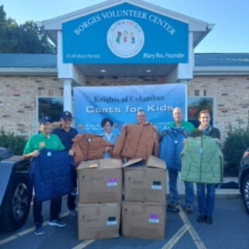
And just like that, Marilyn delivered the coats to Sussex Central High School. Pictured on either side of Marilyn are School Nurse Nicole Oscar and Counselor Mehgan Blades who were grateful that the Knights of Columbus were able to help COK and in turn help their students.
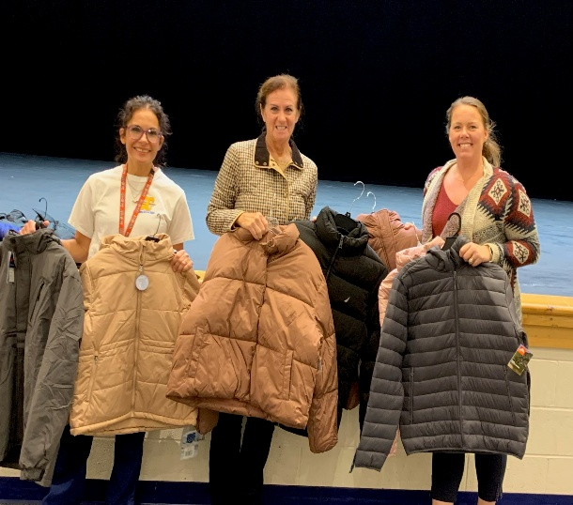
For information regarding Clothing Our Kids (COK), or to donate, please go to www.clothingourkids.org. Kindly pass on the good work of COK by sharing this Update and liking our Social Media posts with your family, friends, neighbors, and colleagues.

